Adult Sunday School

July 8, 2012

Patience, Faith, hope and Love Growing and Abounding

1Th 1:3 Remembering without ceasing your work of faith, and labour of love, and patience of hope in our Lord Jesus Christ, in the sight of God and our Father;
2Th 1:3 We are bound to thank God always for you, brethren, as it is meet, because that your faith groweth exceedingly, and the charity of every one of you all toward each other aboundeth;
4 So that we ourselves glory in you in the churches of God for your patience and faith in all your persecutions and tribulations that ye endure:

- Pray the prayer of Faith without ceasing.
  - Making mention of you in our prayers
  - Remembering without ceasing
  - We, bound to thank God always for you

The Prayer of Faith stirs men to work for the Lord.

What is it that stirs some to work so strong for Jesus and others barely even show that they care.

The effectual fervent Prayer of Faith stirs the heart.
The effectual fervent Prayer of Faith stirs the mind.
The effectual fervent Prayer of Faith stirs the soul.
The effectual fervent Prayer of Faith stirs the spirit.

Heb 11:1 Now faith is the substance of things hoped for, the evidence of things not seen. (10:34)
Patience, Faith and Hope together manifests Love.

Re 3:10 Because thou hast kept the word of my patience, I also will keep thee from the hour of temptation, which shall come upon all the world, to try them that dwell upon the earth.

Patience for the Word is a sign faith is working.
Patience for others is a sign love is working
Patience for yourself is a sign hope is working
Patience for God is a sign Faith, hope and love is working.

Mt 22:37; Mr 12:30; Lu 10:27

1Ti 1:14 And the grace of our Lord was exceeding abundant with faith and love which is in Christ Jesus.

2Ti 1:13 Hold fast the form of sound words, which thou hast heard of me, in faith and love which is in Christ Jesus.
Heb 10:23 Let us hold fast the profession of our faith without wavering; (for he is faithful that promised;)
Jas 2:24 Ye see then how that by works a man is justified, and not by faith only.

Mr 4:40 And he said unto them, Why are ye so fearful? how is it that ye have no faith?

Lu 8:25 And he said unto them, Where is your faith? And they being afraid wondered, saying one to another, What manner of man is this! for he commandeth even the winds and water, and they obey him.
Jude 1:3 earnestly contend for the faith which was once delivered unto the saints.
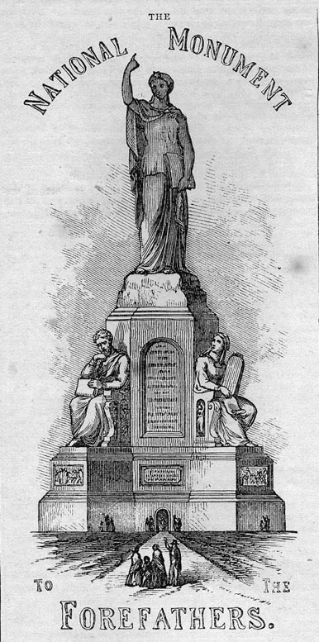

A stairway leads to the platform upon which stands the figure of Faith. The whole monument is about 150 feet high, and 80 feet at the base. The Statue of Faith rests her foot upon the Forefather's Rock; in her left hand she, holds an open Bible; with the right hand lifted up she points to heaven. Looking downward, as to those she is addressing, she calls them to trust in God. The sitting figures are emblematic of the principles upon which the Pilgrims proposed to found their Commonwealth.

De 32:20 And he said, I will hide my face from them, I will see what their end shall be: for they are a very froward generation, children in whom is no faith.
The first is Morality.
- She holds the Ten Commandments in her left, and the Scroll of Revelation in her right hand.
- Her look is upward, towards heaven.
- In a niche, on one side of her throne, is a Prophet, and in the other, one of the Evangelists.
The second is Law.
- On one side of his seat is Justice;
- On the other, Mercy.
The third is Education.
- On one side of her seat, is Wisdom, ripe with years;
- On the other, Youth, led by Experience.
The fourth is Freedom.
- On one side, Peace rests under his protection;
- On the other, Tyranny overthrown by his prowess.
The Statue of Faith itself is 70 feet high, and the sitting figures are 38 feet high, — Making it in magnitude the greatest work of its kind in the world; It will afford insight and pleasure to every American citizen.
Jos 4:6 “ this may be a sign among you…What mean ye by these stones? 7… these stones shall be for a memorial unto the children of Israel for ever.21 …What mean these stones?

